# Html and Css Design

The LiEat Fanspage

190576688 Tsui Ka Ying Karen MTI

The Special Feature

1. I use an animation to the image to make them look it pressing

1. For the Hover part, I have use some transition of some hover interaction.

Like when you hover to the icon, the icon will change, and the hovering icon will start bouncing.

I mainly using transition commend like “transition:opacity 1.5s ease-in-out,transform 1s ease-in-out;”

and some of them I used @keyframe to make animation self-designed.

Like this hover slide out intro, it is using :

“animation:sliding 0.7s ease-in-out both;

animation-play-state:paused;”

to make a middle-stop and start of the animation. I use position:

Hover2

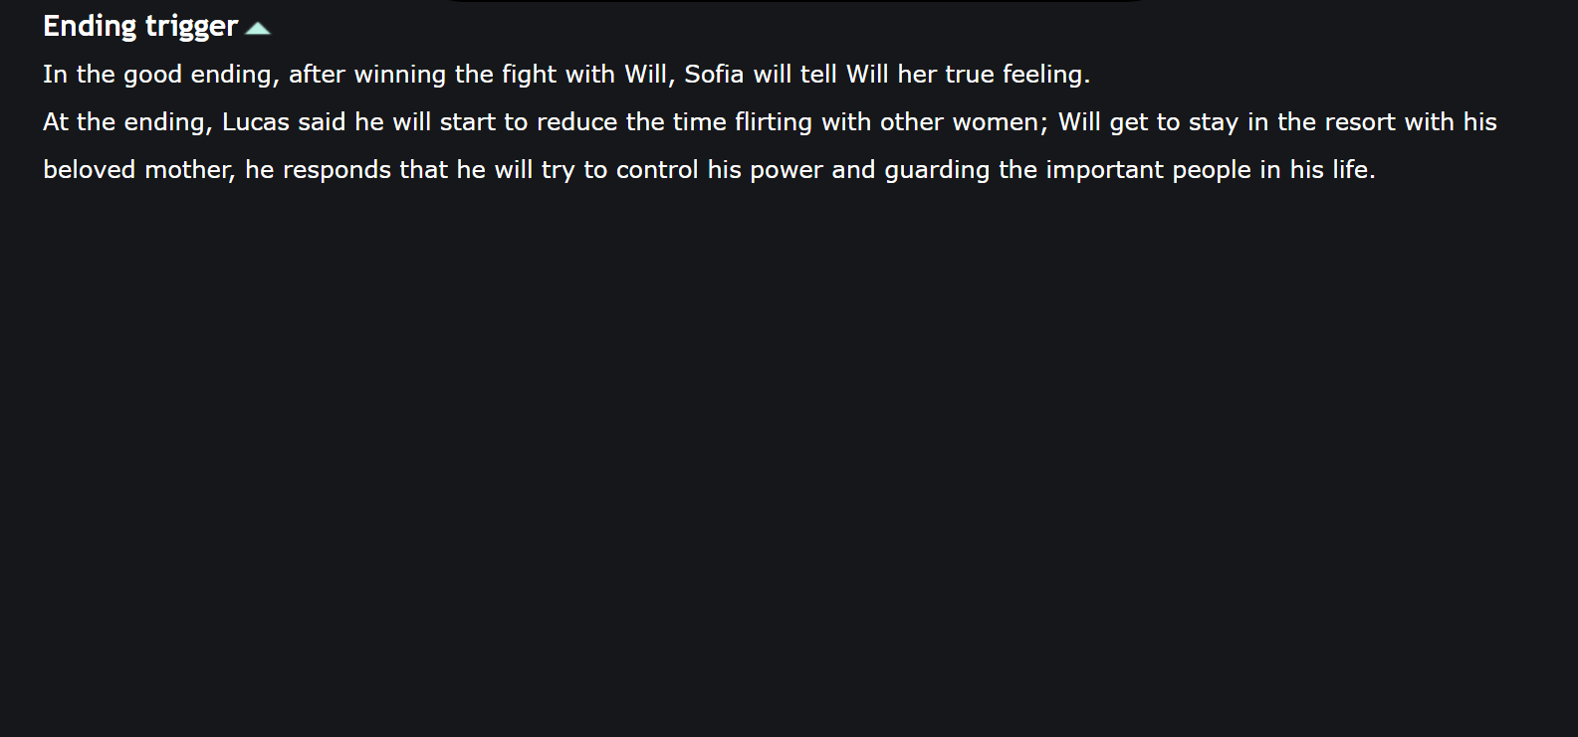I separated the special information, in a “display:none” and release it when hovering it the “display: block;” will active. The hidden information will be uncovered.

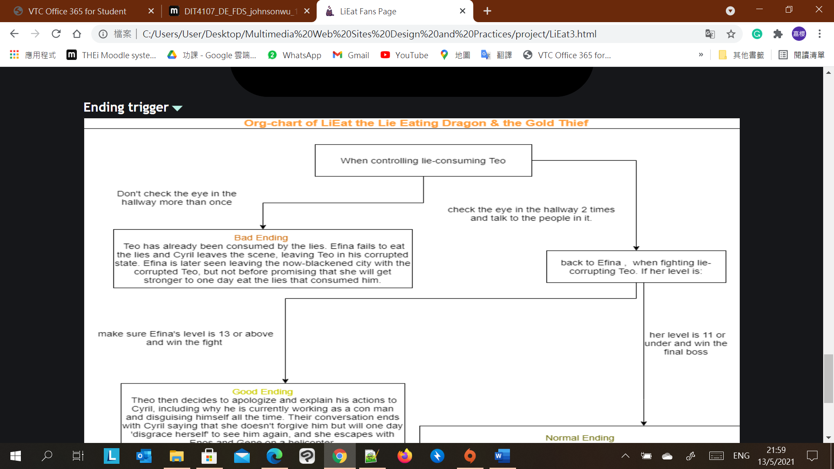

1. For the relationship group part, 一張含有 文字, 螢幕擷取畫面, 螢幕 的圖片

   自動產生的描述

I used the <fieldset> element for the grouping the character because I think it is easier to divide into different positions.

1. For the form, I have using a little JavaScript for the conditional option of the Yes and No from the Lab8 JavaScript 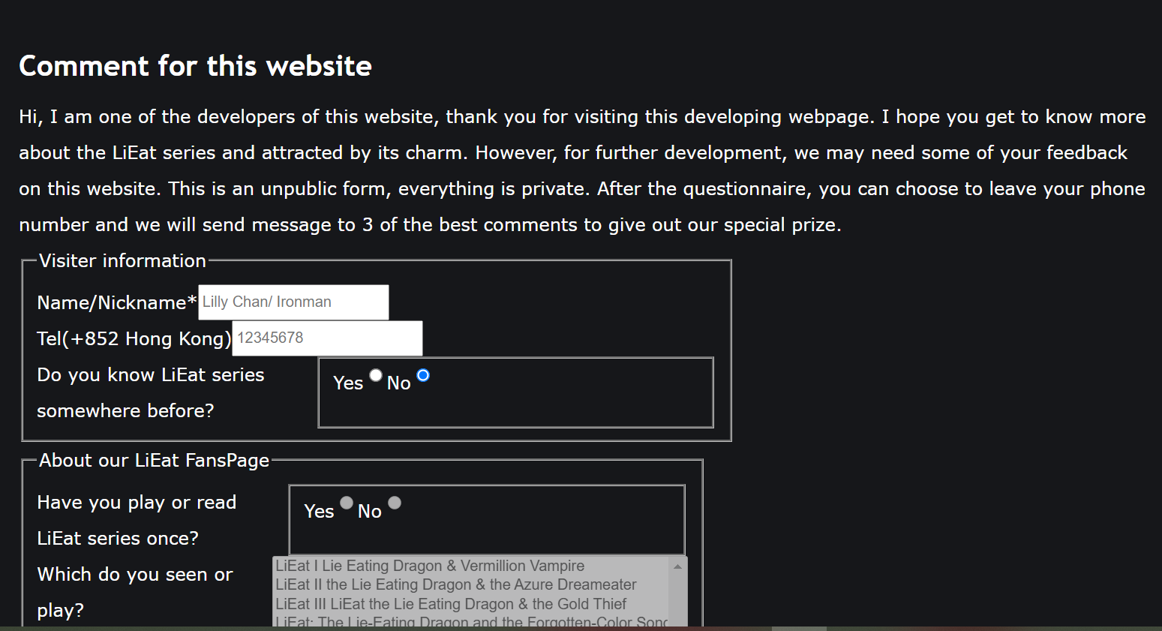

1. For the responsive layout, I use flexible displays for most of the layout and adjust it with @media only screen and (max-width:600px){} conditions. When the screen is 600px of the mobile devices, its will change to fit the device. 一張含有 文字, 室內, 組, 差異 的圖片

   自動產生的描述

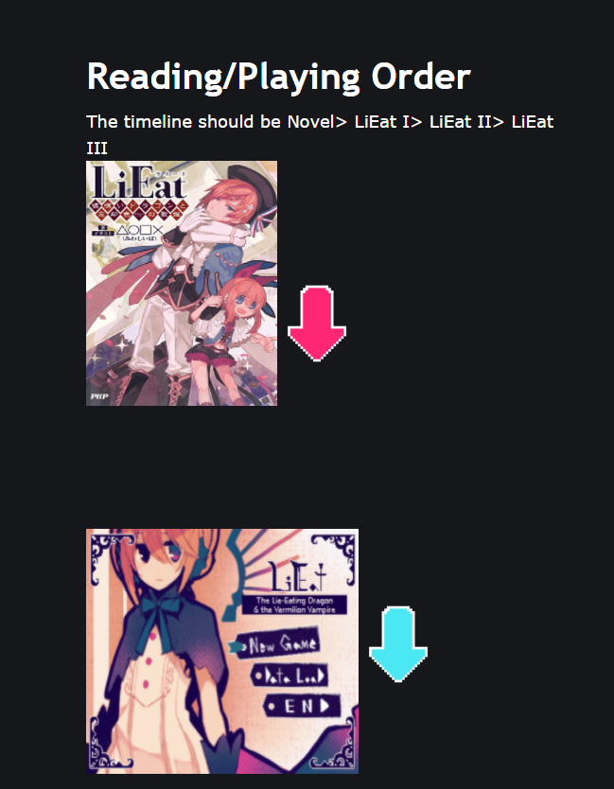

Like this display when the device not PC, its font size and figures will turn smaller, and the arrow will rotate downwards.

For the normal display

Because I am not good at layout, so I mostly use aside and article for the fix content with few captures.

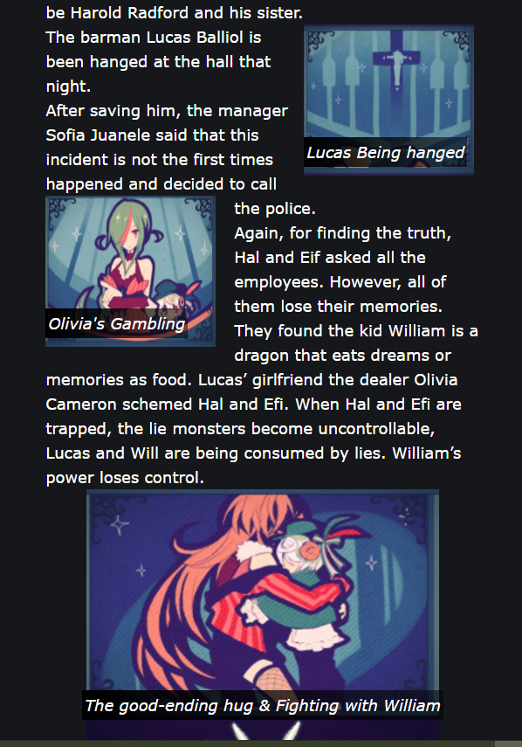

Source:

**Content:**

My content is mainly use my year 1 report of LiEat

**Video:**

The video is coming from my early Gameplay of LiEat

<https://youtube.com/playlist?list=PL5pIoO8dBfJSmA6zHp9UE2GY6pQyLe3KY>

**Character & title image:**

LiEat Fandom is a great game fanspage

<https://lieat.fandom.com/wiki/LiEat_Wiki>

**Most of the Logo location**

Some of them is hand-made and some of them is on the internet:

<https://www.jointpublishing.com/bookstore/chinese-books/popular-reading/h_comics/9789864757572.aspx>

**sound**

The sound is mainly from the LiEat official soundtracks:

<https://www.youtube.com/watch?v=LftULukbKKw>

<https://www.youtube.cohttps://www.youtube.com/watch?v=CZcVZJEfbRcm/watch?v=GjZ1f9cKxaA&t=94>

<https://www.youtube.com/watch?v=w8wHkoBBqjo>

<https://www.youtube.com/watch?v=CZcVZJEfbRc>